

**Bachelor of Computer Science**

**(Digital System Security)**

CSCI321 – Final Year Project

Database Design Document

**Project Particulars**

|  |  |
| --- | --- |
| Supervisor | Dr Ta Nguyen Binh Duong |
| Project Group | SS18/1F |
| Project Title | Two Factor Authentication |

**Project Team’s Particulars**

|  |  |  |
| --- | --- | --- |
| Student Number | Student Name | Email Address |
| 5363536 | Koh Hong Wei | hwkoh003@mymail.sim.edu.sg |
| 5710923 | Chua Han Ming Adler | hmachua002@mymail.sim.edu.sg |
| 5711356 | Ong Wei Hao | whong012@mymail.sim.edu.sg |

Table of Contents

1. Introduction 3

1.1. Document Objective 3

1.2. Intended Audience 3

2. Object Diagram 4

3. Conceptual Diagram 4

3.1 Conceptual Diagram Description 5

4. Data Design 5

4.1. User Table 5

4.1.1. Purpose of User Table 5

4.1.2. Data Dictionaries for Element: USER 5

4.2. File Table 5

4.2.1. Purpose of File Table 5

4.2.2. Data Dictionaries for Element: FILE 5

4.3. Login Table 6

4.3.1. Purpose of File Table 6

4.3.2. Data Dictionaries for Element: LOGIN 6

4.4. Table Relations 6

# 1. Introduction

The section introduces the Database Design Document (DDD) for Go2FA to its readers.

## 1.1. Document Objective

This DDD for the Go2FA software has the following activities:

* To serve as the basis for implementing the database
* Describe the design of SQL database

## 1.2. Intended Audience

This DDD is intended for the following audiences:

* Supervisor, Invigilator, or any related audiences who will evaluate the quality of this document and access the product base on this document.
* Go2FA developers including:
  + Architects – whose overall architecture must meet the requirement specified in this document.
  + Designers – whose design must meet the requirements specified in this document.
  + Software Programmers – whose software must implement the requirements specified in this document.
  + Penetration Testers – whose test cases must validate the requirements specified in this document.

# 2. Object Diagram

An object diagram to show a given instance of the database.

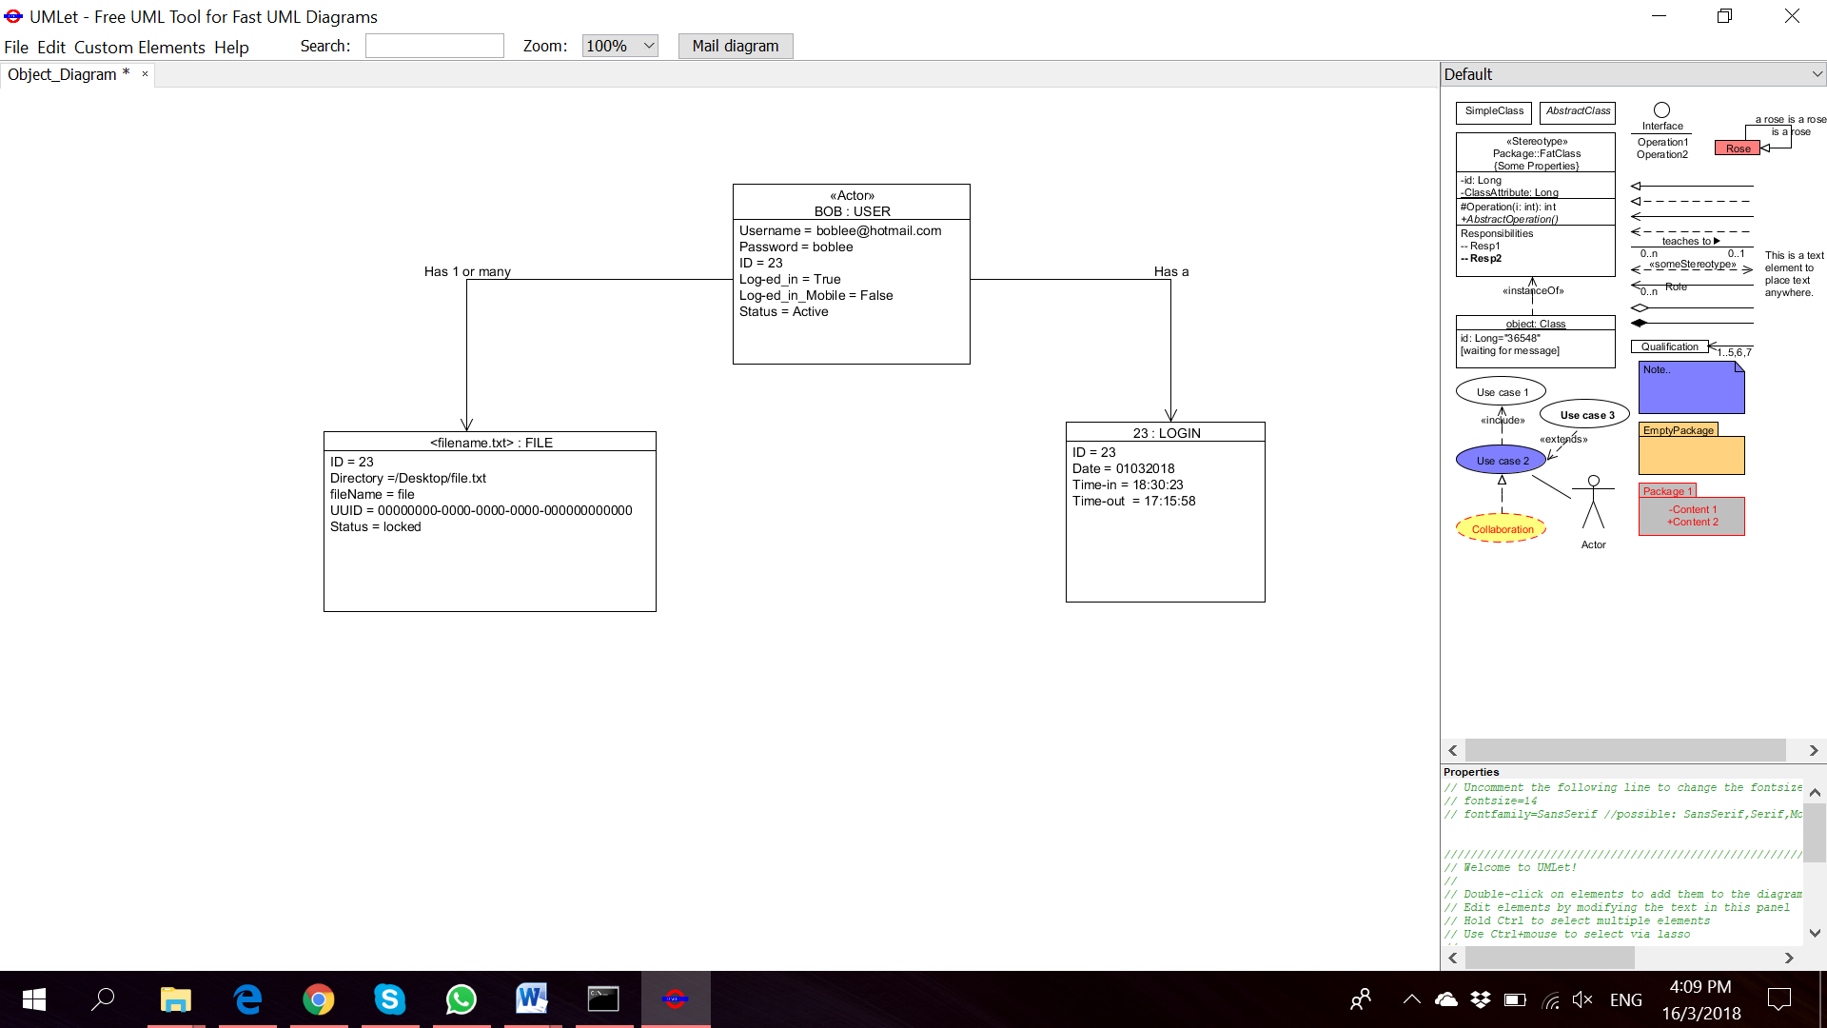

# 3. Conceptual Diagram

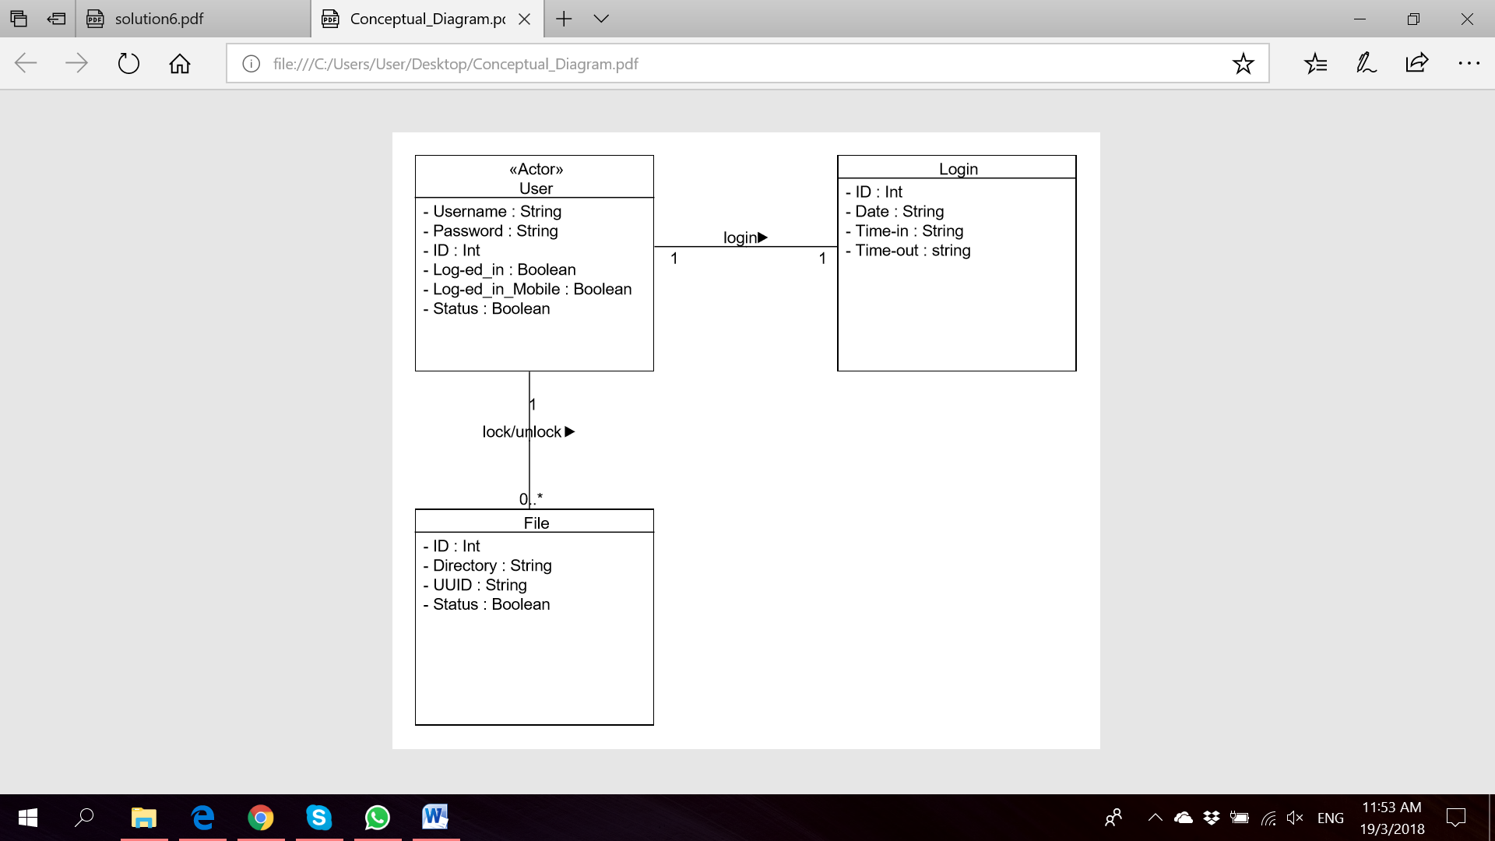

## 3.1 Conceptual Diagram Description

This diagram displays the conceptual model of the SQL database. This database will be created after a user has signed-up an account on the application itself. The user session will have the user’s details that is currently logged in and active. The details of his login, time in and time out will be recorded. User will then have an option to lock or unlock zero or more files.

# 4. Data Design

## 4.1. User Table

### 4.1.1. Purpose of User Table

This table stores the information of the users that are authorised to use the application after signing up. The information includes, login information, the username and password, an ID generated by the system to uniquely identify a user besides the username, logged in status to display if the user is currently active on the applications and lastly the status of the application.

### 4.1.2. Data Dictionaries for Element: USER

|  |  |  |  |
| --- | --- | --- | --- |
| **Name** | **Data Type** | **Constrain** | **Description** |
| ID (Primary key) | Int | Min:1, Max:1 | Unique ID generate for the user |
| Username (Candidate key) | String | Min:1, Max:1 | Email ID of user |
| Password | String | Min:1, Max:1 | Password of user |
| Log-ed_in | Boolean |  | Log in status for Desktop app |
| Log-ed_in_Mobile | Boolean |  | Log in status for Mobile app |
| Status | Boolean |  | Account status |

USER (ID, Username, Password, Log-ed_in, Log-ed_out, Status)

Primary Key : ID

Candidate Key : Username

## 4.2. File Table

### 4.2.1. Purpose of File Table

This table stores the information of the files before or after actions done by the user. The information includes the ID of the owner of the file together with the directory of the file and the UUID of the machine to uniquely identify the file, the file’s name and the status of the file that reflects if it is locked or unlocked

### 4.2.2. Data Dictionaries for Element: FILE

|  |  |  |  |
| --- | --- | --- | --- |
| **Name** | **Data Type** | **Constrain** | **Desciption** |
| ID (Composite key) | Int | Min:1, Max:1 | Unique ID of the user |
| Directory (Composite key) | String | Min:1, Max:1 | Local directory of the file |
| Filename | String |  | Nameof file |
| UUID (Composite key) | String | Min:1, Max:1 | UUID of local machine |
| Status | Boolean |  | File locked or unlocked |

FILE (ID, Directory, Filename, UUID)

Composite Key : ID, Directory, UUID

Foreign Key : ID references USER (ID)

## 4.3. Login Table

### 4.3.1. Purpose of File Table

This table stores the login information of the user. The information includes the ID of the user, together with the date and time that the user logged in at to uniquely identify each session. And also the time when the user logged out.

### 4.3.2. Data Dictionaries for Element: LOGIN

|  |  |  |  |
| --- | --- | --- | --- |
| **Name** | **Data Type** | **Constrain** | **Description** |
| ID (Composite key) | Int | Min:1, Max:1 | Unique ID of the user |
| Date (Composite key) | Date | Min:1, Max:1 | Date of login |
| Time-in (Composite key) | Time | Min: 1, Max: 1 | Time of login |
| Time-out | Time | Min: 1, Max: 1 | Time of logout |

LOGIN (ID, Date, Time-in, Time-out)

Composite Key : ID, Date, Time-in, Time-out

Foreign Key : ID references USER (ID)

## 4.4. Table Relations

|  |  |  |
| --- | --- | --- |
| **From Table** | **To Table** | **Relation** |
| User | File | A user may lock/unlock multiple files or directory |
| User | Login | A user will login |
| File | Login | There might be multiple files having actions done to on a single login session |